**Red Team: Summary of Operations**

Madeleine Simpson

**-Exploitation of Target 1-**

**Table of Contents:**

**-Exposed Services**

**-Critical Vulnerabilities**

**-Exploitation**

**Exposed Services**

Nmap scan results for each machine reveal the below services and OS details:

Command: nmap -sV 192.168.1.0,90-115

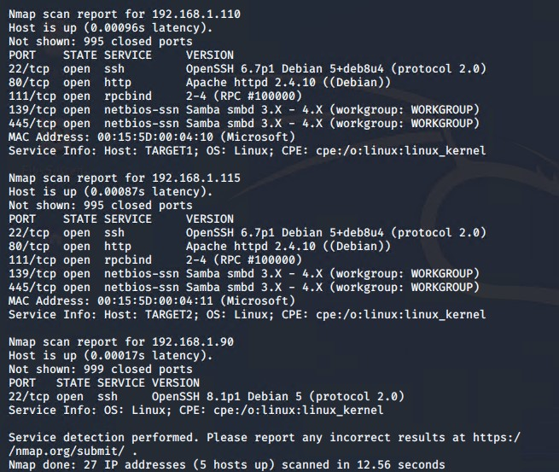

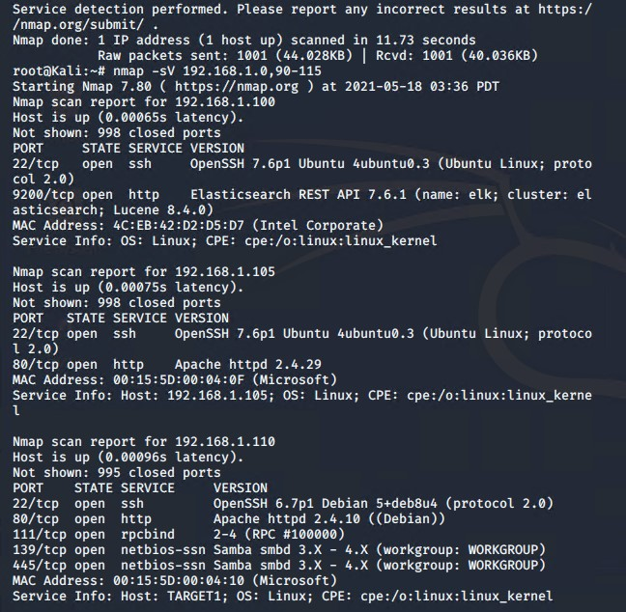

**This scan identifies the services below as potential points of entry:**

* Port 22 (ssh)
* Port 80 (http)
* Port 111 (rpcbind)
* Port 139 (netbios-ssn)
* Port 445 (netbios-ssn)

**Critical Vulnerabilities**

**The following vulnerabilities were identified on the target:**

* Port 22 open (allows us to ssh with discovered credentials)
* Port 80 open (allows us physical access to the http server

**Exploitation**

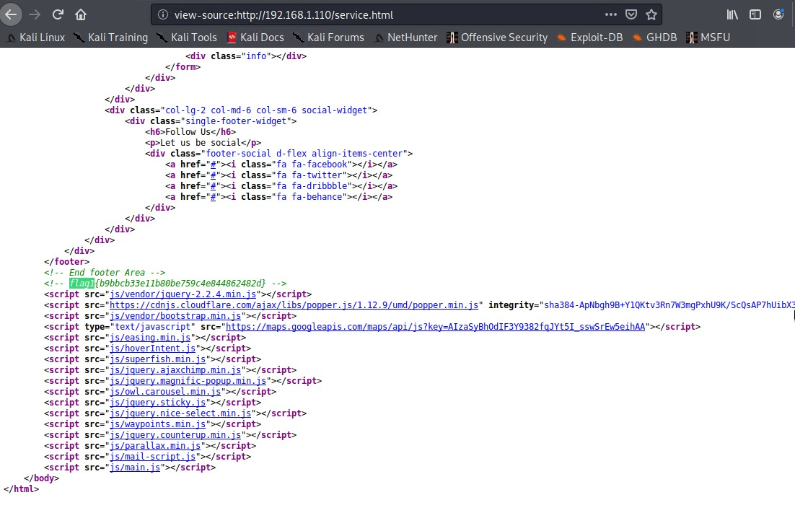**Exploit Used:** Open port 80, checked source code.

**\*Exploited wordpress vulnerabilities\***

**Command:** wpscan --url <http://192.168.1.110/wordpress> -eu

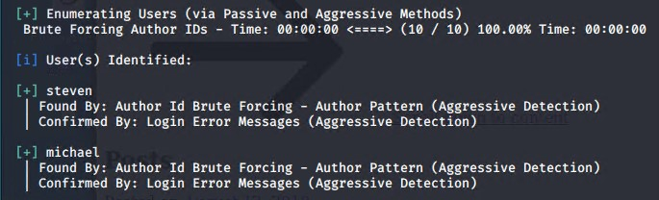

*Identified Target users*

**\*Exploited weak password\***

**Command:** ssh michael@192.168.1.110

*Password same as username, access gained via michael credentials*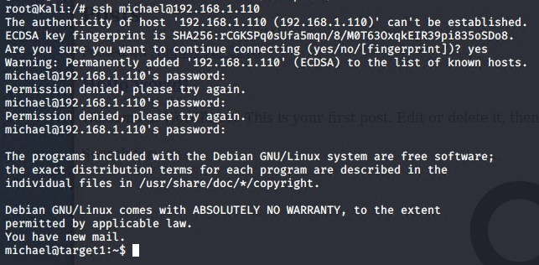

**\*Located config.php file\***

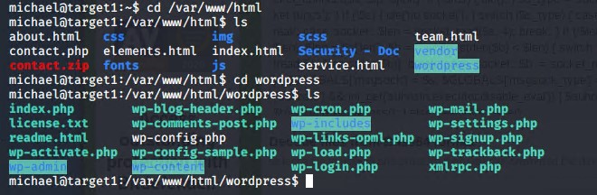

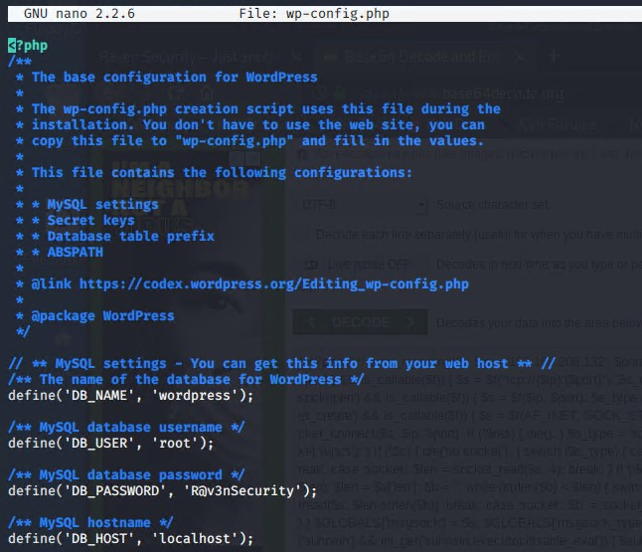*Config file revealed some login credentials*

**\*logged in to mySQL with credentials root + R@v3nSecurity\***

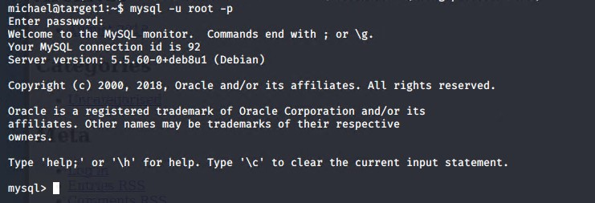

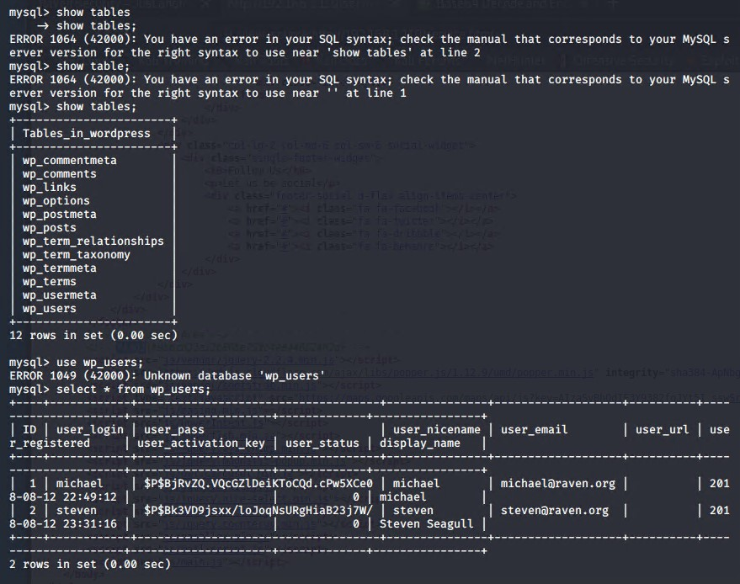

*Located password hashes for michael and steven*

**\*Created file containing michael and steven password hashes and cracked using john the ripper\***

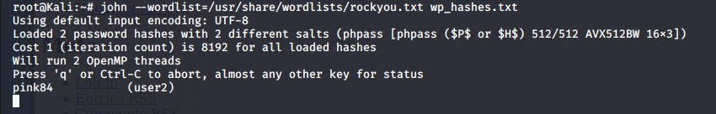**\*Steven password identified as ‘pink84, created shell using steven’s credentials\***

\***Ran python script to escalate to root access\***